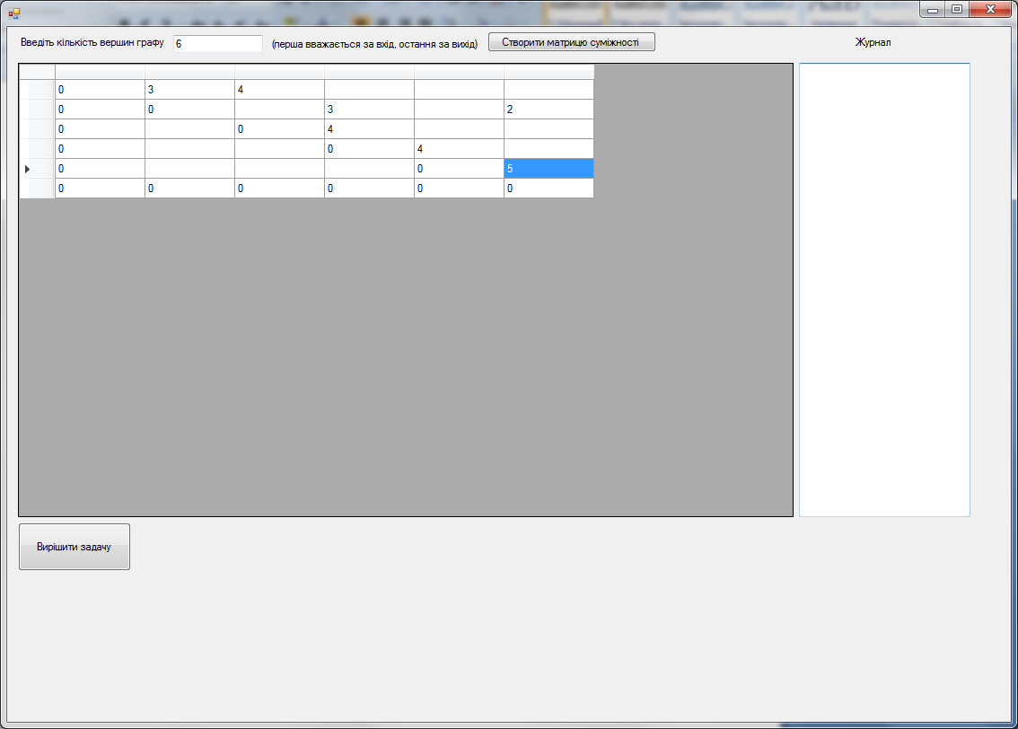

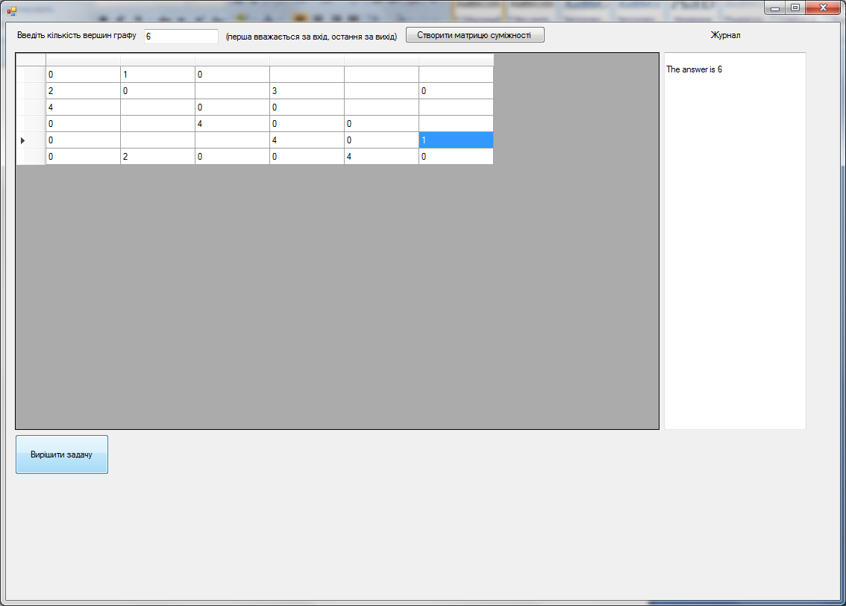

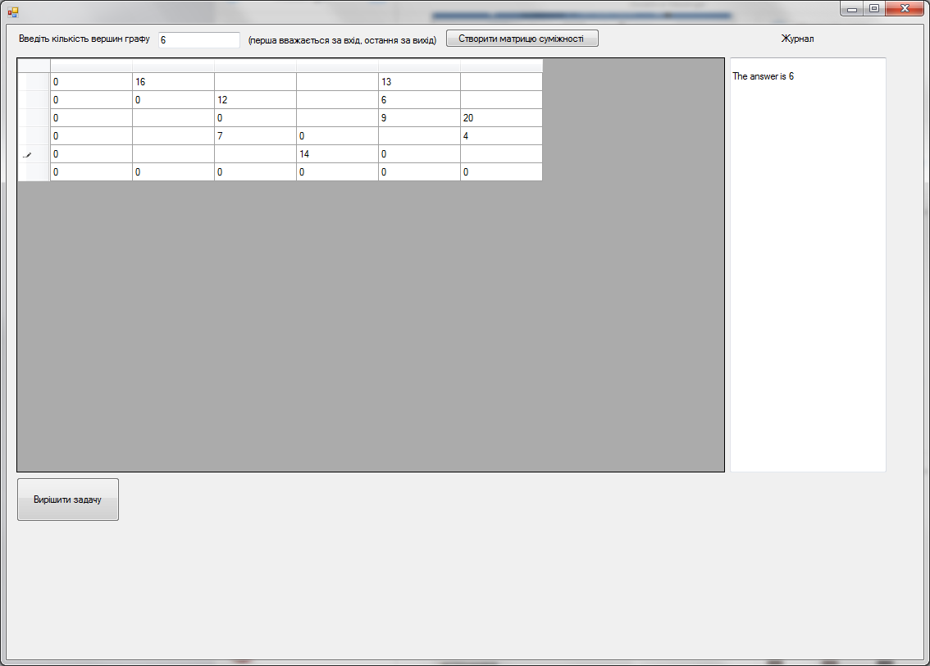

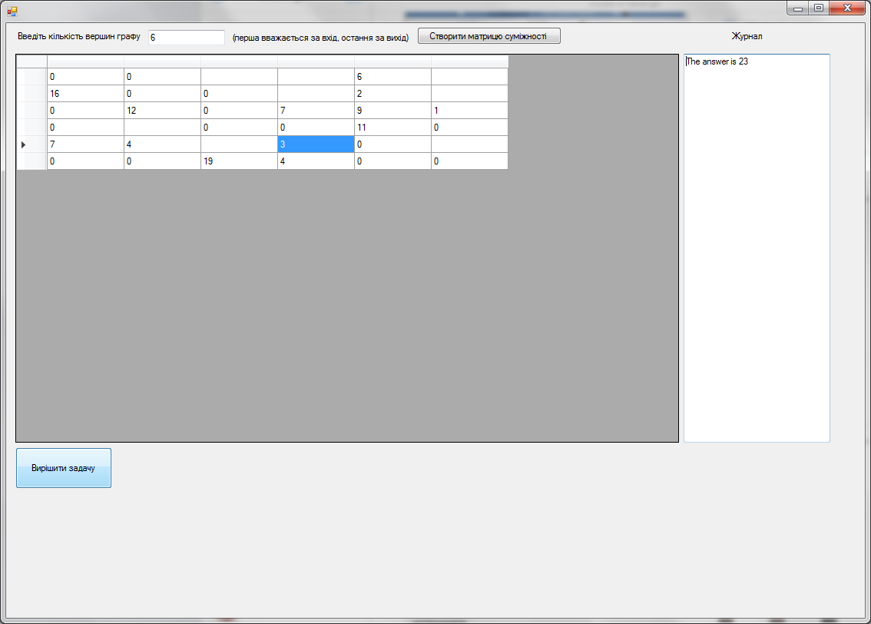

Код програми:

if(dataGridView1.Columns.Count<=1)

{

textBox3.Text += "You shall create graph" + Environment.NewLine;

return;

}

int i,j;

int NumOfVec = dataGridView1.Columns.Count;

int Check;

try

{

for (i = 0; i < NumOfVec; i++)

{

for (j = 0; j < NumOfVec; j++)

{

if(dataGridView1.Rows[i].Cells[j].ReadOnly==false)

{

Check = Convert.ToInt32(dataGridView1.Rows[i].Cells[j].Value);

if (Check < 0)

throw new Exception();

}

}

}

}

catch

{

textBox3.Text += "Wrong input" + Environment.NewLine;

return;

}

List<Way> CurWays;

List<Way> LastWays;

int AllStream = 0;

bool StepMade;

bool MoveMade = true;

bool DeleteNeeded = false;

int Temp;

while(MoveMade)

{

StepMade = true;

MoveMade = false;

CurWays = new List<Way>();

LastWays = new List<Way>();

LastWays.Add(new Way(0));

while(StepMade)

{

CurWays = new List<Way>();

//CurWays = LastWays;

StepMade = false;

for (i = 0; i < LastWays.Count; i++)

{

//DeleteNeeded = true;

if(LastWays[i].CurWay[LastWays[i].CurWay.Count-1]==(dataGridView1.Rows.Count-1))

{

CurWays.Add(LastWays[i]);

//StepMade = false;

continue;

// DeleteNeeded = false;

}

for (j = 0; j < dataGridView1.ColumnCount; j++)

{

if (Convert.ToInt32(dataGridView1.Rows[LastWays[i].CurWay[LastWays[i].CurWay.Count - 1]].Cells[j].Value) != 0)

{

CurWays.Add(new Way(LastWays[i]));

CurWays[CurWays.Count - 1].AddPoint(j,Convert.ToInt32(dataGridView1.Rows[LastWays[i].CurWay[LastWays[i].CurWay.Count - 1]].Cells[j].Value));

DeleteNeeded = false;

StepMade = true;

if (CurWays[CurWays.Count - 1].CheckCycle())

{

CurWays.RemoveAt(CurWays.Count - 1);

}

}

}

/\*if (DeleteNeeded)

{

LastWays.RemoveAt(i);

i--;

}\*/

}

LastWays = CurWays;

}

LastWays.Sort();

if (LastWays.Count!=0 && (LastWays[LastWays.Count - 1].MinVal != 0 || LastWays[LastWays.Count - 1].MinVal != int.MaxValue ))

{

AllStream+=LastWays[LastWays.Count - 1].MinVal;

for (i = 1; i < LastWays[LastWays.Count - 1].CurWay.Count;i++ )

{

dataGridView1.Rows[LastWays[LastWays.Count - 1].CurWay[i - 1]].Cells[LastWays[LastWays.Count - 1].CurWay[i]].Value = Convert.ToInt32(dataGridView1.Rows[LastWays[LastWays.Count - 1].CurWay[i - 1]].Cells[LastWays[LastWays.Count - 1].CurWay[i]].Value) - LastWays[LastWays.Count - 1].MinVal;

dataGridView1.Rows[LastWays[LastWays.Count - 1].CurWay[i]].Cells[LastWays[LastWays.Count - 1].CurWay[i - 1]].Value = Convert.ToInt32(dataGridView1.Rows[LastWays[LastWays.Count - 1].CurWay[i]].Cells[LastWays[LastWays.Count - 1].CurWay[i-1]].Value) + LastWays[LastWays.Count - 1].MinVal;

}

MoveMade = true;

}

}

textBox3.Text += "The answer is " + AllStream + Environment.NewLine;